**DAILY ONLINE ACTIVITIES SUMMARY**

|  |  |  |  |  |  |  |  |  |
| --- | --- | --- | --- | --- | --- | --- | --- | --- |
| **Date:** | **11-06-2020** | | | | | **Name:** | **Anusha** | |
| **Sem & Sec** | **VIII Semester & A Section** | | | | | **USN:** | **4AL16CS014** | |
| **Online Test Summary** | | | | | | | | |
| **Subject** | | **SMS** | | | | | | |
| **Max. Marks** | | **60** | | **Score** | | | **60** | |
| **Certification Course Summary** | | | | | | | | |
| **Course** | **Introduction to Hadoop 3.0** | | | | | | | |
| **Certificate Provider** | | | **Great Learning** | | **Duration** | | | **3 hour** |
| **Coding Challenges** | | | | | | | | |
| **Problem Statement: Write a program in C to display full pyramid of numbers** | | | | | | | | |
| **Status: COMPLETED** | | | | | | | | |
| **Uploaded the report in Github** | | | | | **YES** | | | |
| **If yes Repository name** | | | | | **anushasuvarna-014** | | | |
| **Uploaded the report in slack** | | | | | **YES** | | | |

Online Test Details:

Certification Course:

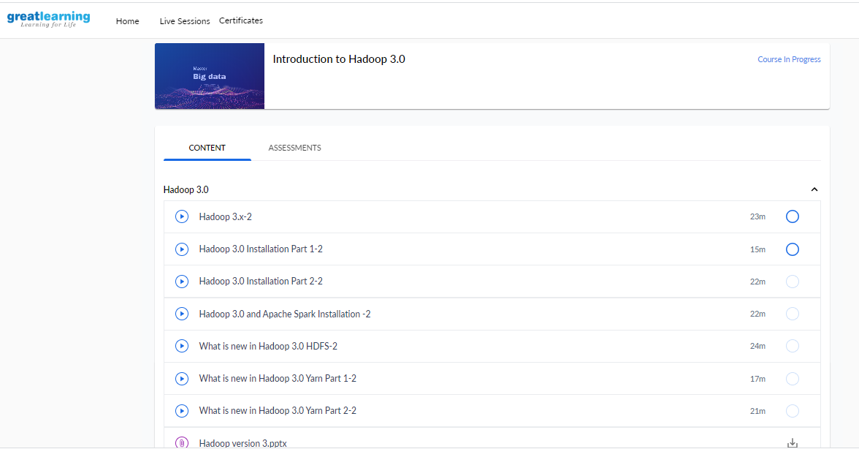

Coding Challenges Details:

**Program1:**

**#include <stdio.h>**

**int main() {**

**int i, space, rows, k = 0, count = 0, count1 = 0;**

**printf("Enter the number of rows: ");**

**scanf("%d", &rows);**

**for (i = 1; i <= rows; ++i) {**

**for (space = 1; space <= rows - i; ++space) {**

**printf(" ");**

**++count;**

**}**

**while (k != 2 * i - 1) {**

**if (count <= rows - 1) {**

**printf("%d ", i + k);**

**++count;**

**} else {**

**++count1;**

**printf("%d ", (i + k - 2 * count1));**

**}**

**++k;**

**}**

**count1 = count = k = 0;**

**printf("\n");**

**}**

**return 0;**

**}**